Spring boot CASHING

@Eanablecaching >>>>>>>>>>use with @SpingbootApplication

@cacheconfig  
  
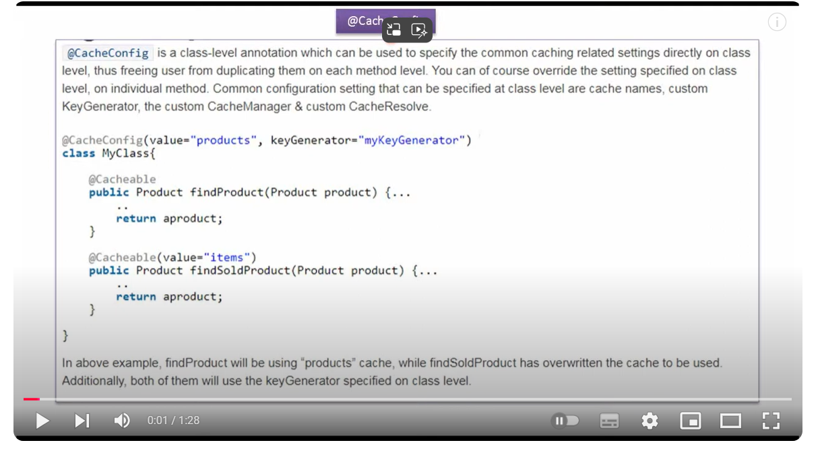

@Cacheput >>>>>>>>>>>>update  
@cacheveit >>>>>>>>>delete   
@**Cacheable >>>>>>>>>getdata**   
@**Caching**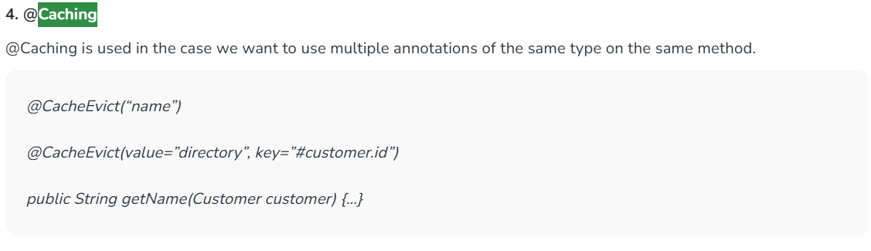

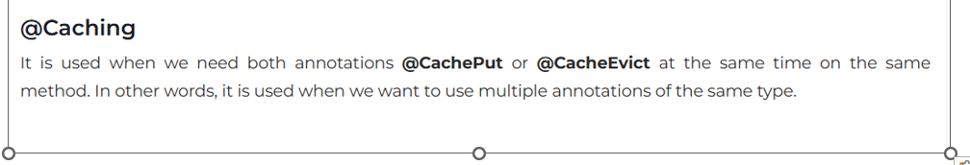

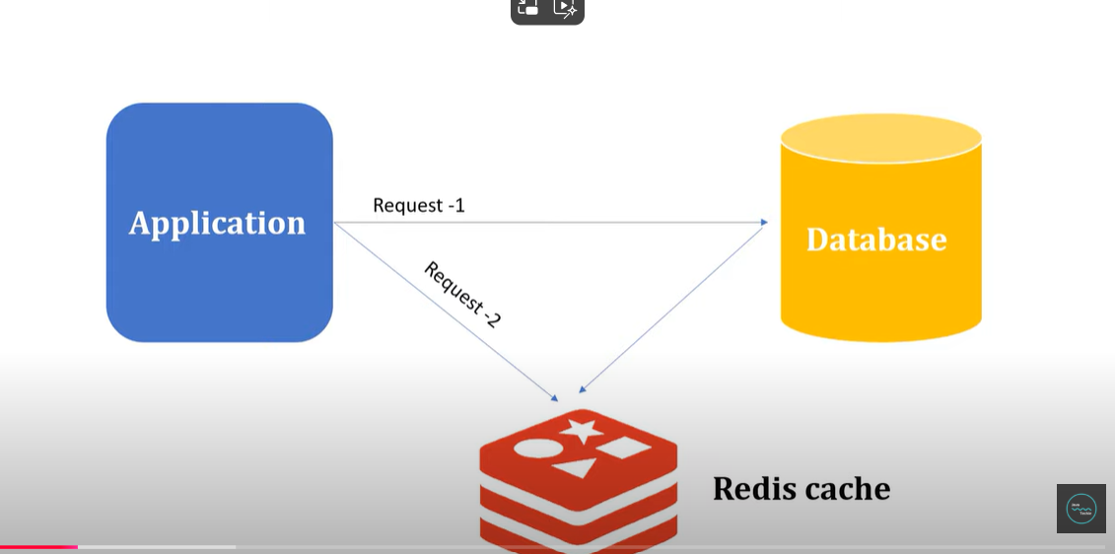  
  
Console blank retrieve from cache.  
  
  
  
  
Data will store in Ram non second Record.  
  
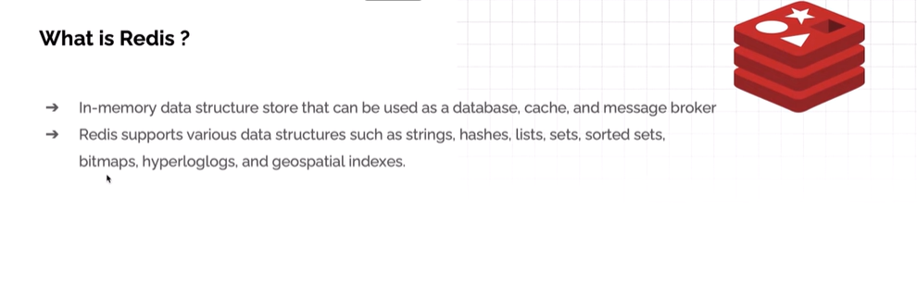  
Need to download and install Radis

[What is Caching? || Why do we need Caching? || Spring Boot Caching || Green Learner](https://www.youtube.com/watch?v=d0ui0x4Sw2w&list=PLq3uEqRnr_2HY6LMQsbvsK4btj51sWhBS&index=1)  
  
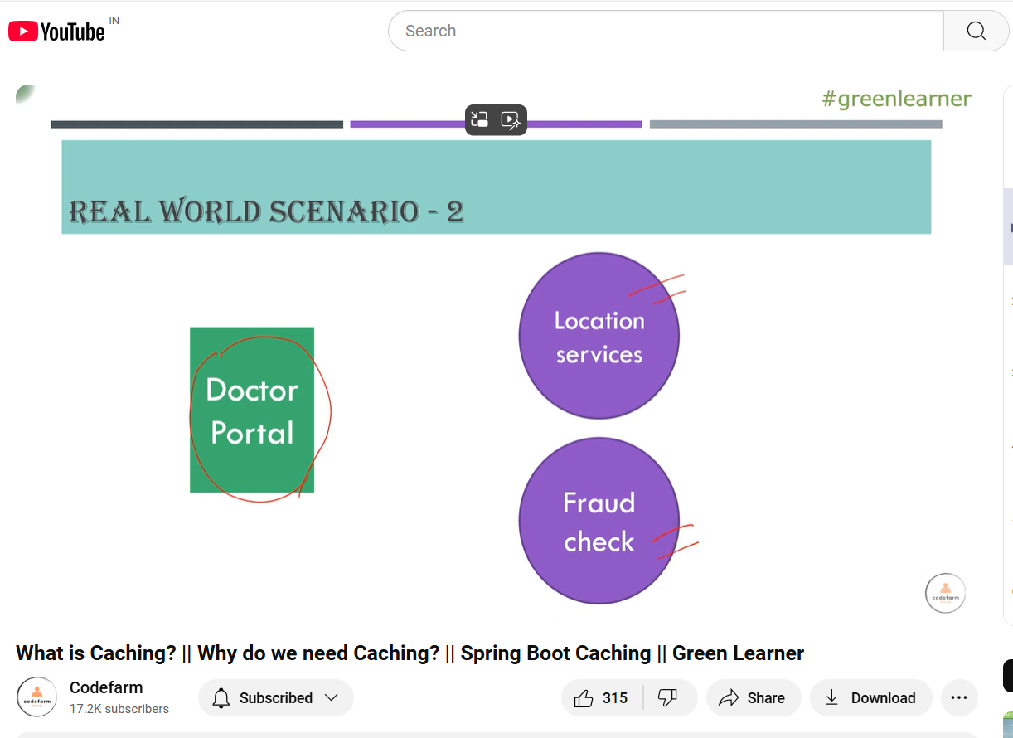  
  
[87.Spring boot Cache Eaxmple_PART1](https://www.youtube.com/watch?v=XNaaol4YFjc&list=PLzS3AYzXBoj-oq5jP6isGbPqexKtmHsRI)

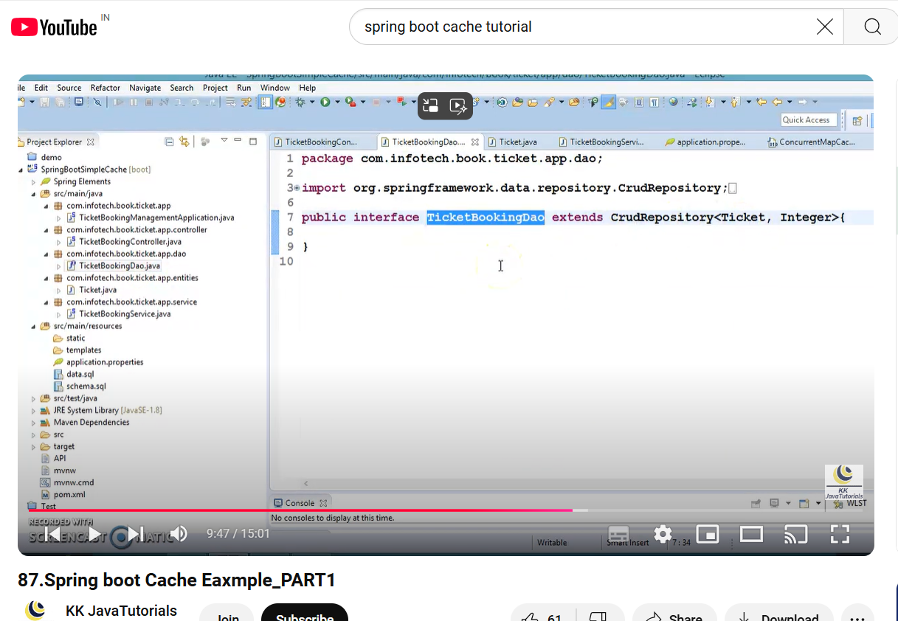  
  
  
[Step-by-Step Guide to Spring Boot CRUD with Redis in Hindi](https://www.youtube.com/watch?v=lXK8RS40v9c)  


  
  
  
  
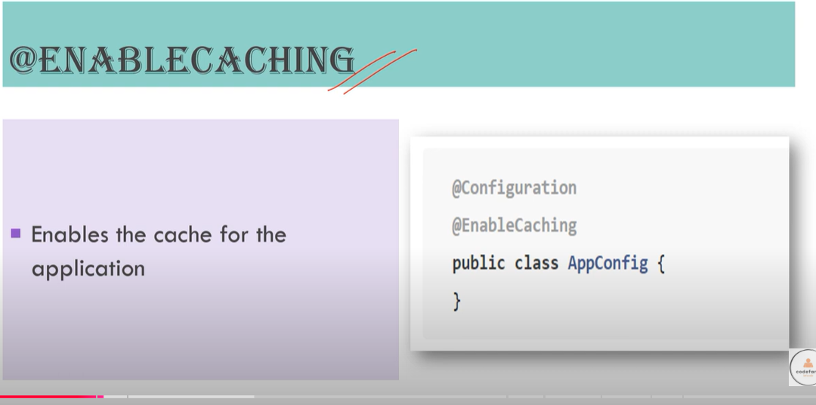  
  
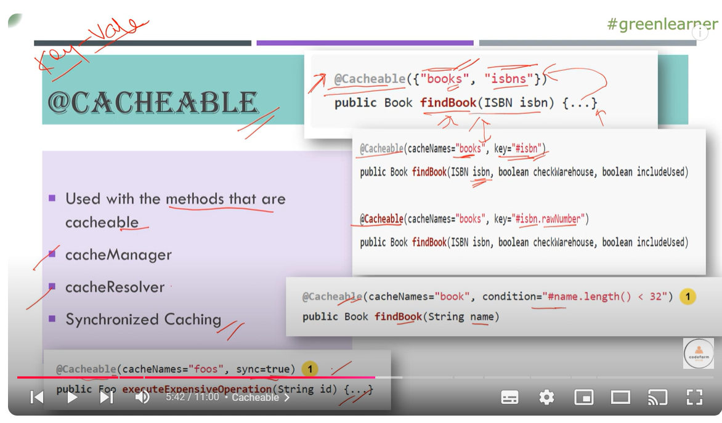

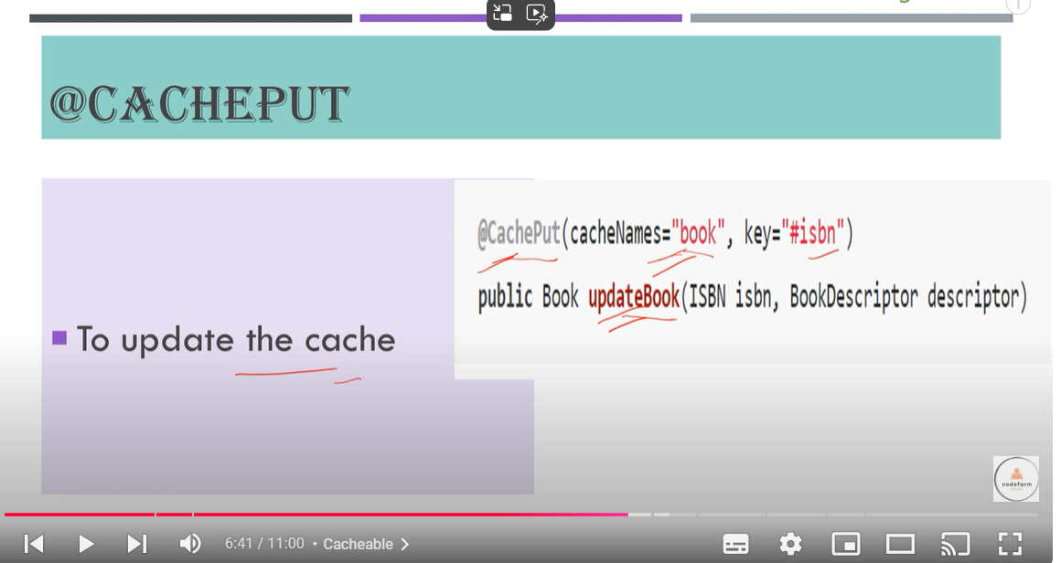

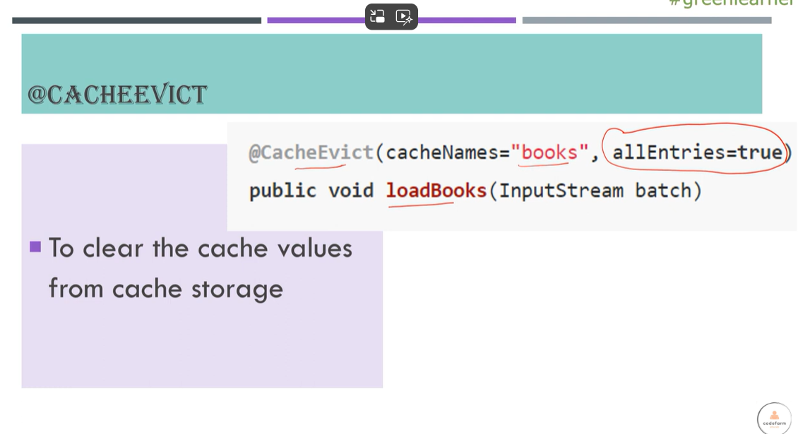  
  
  
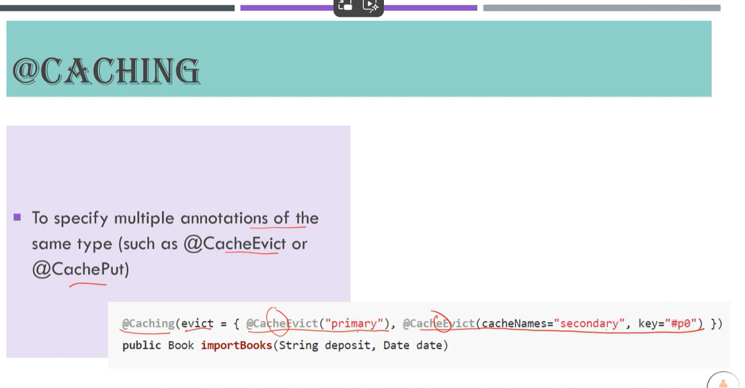

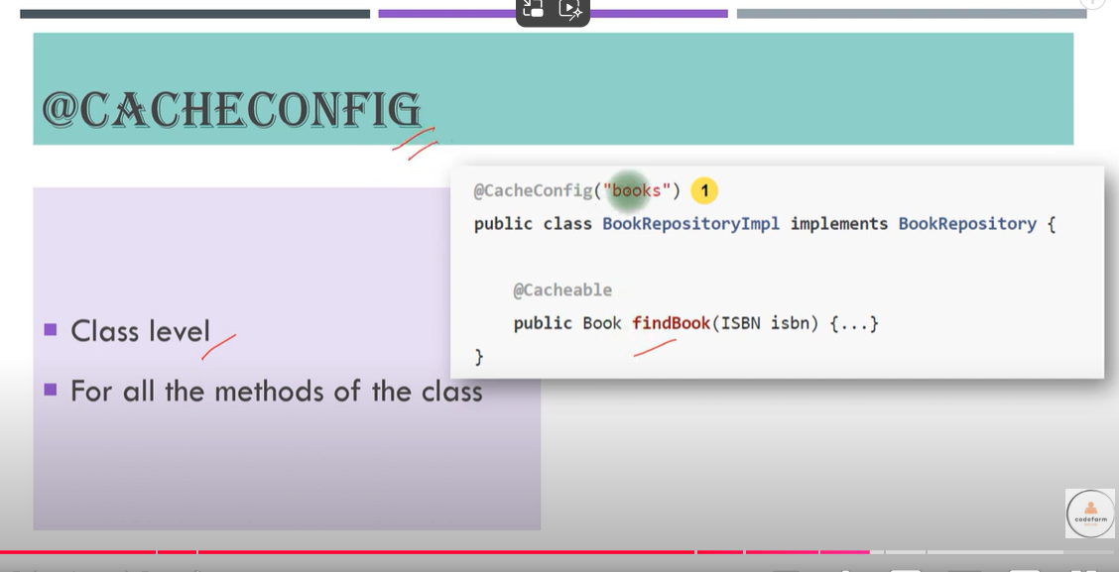

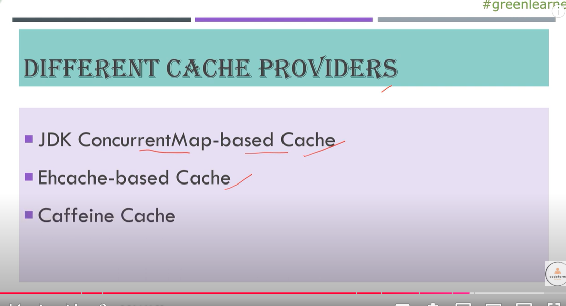

Curd Operation

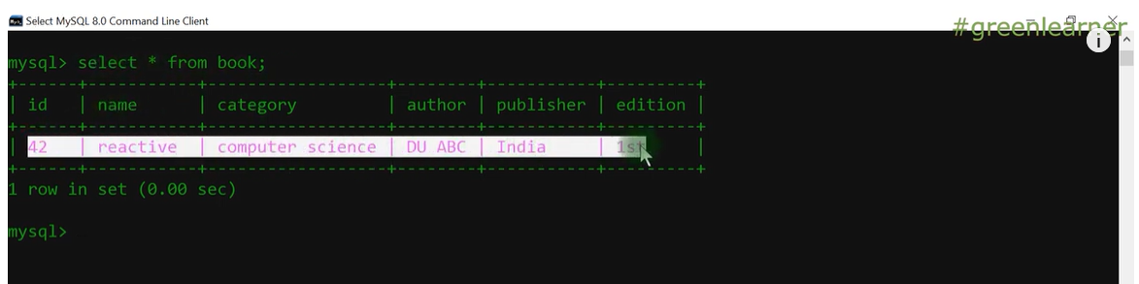  
  
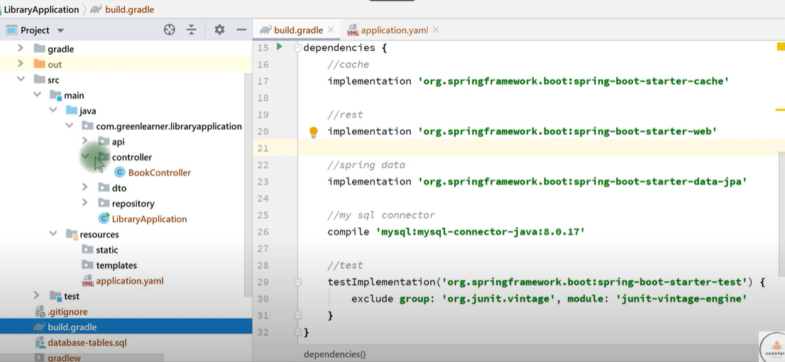  
  
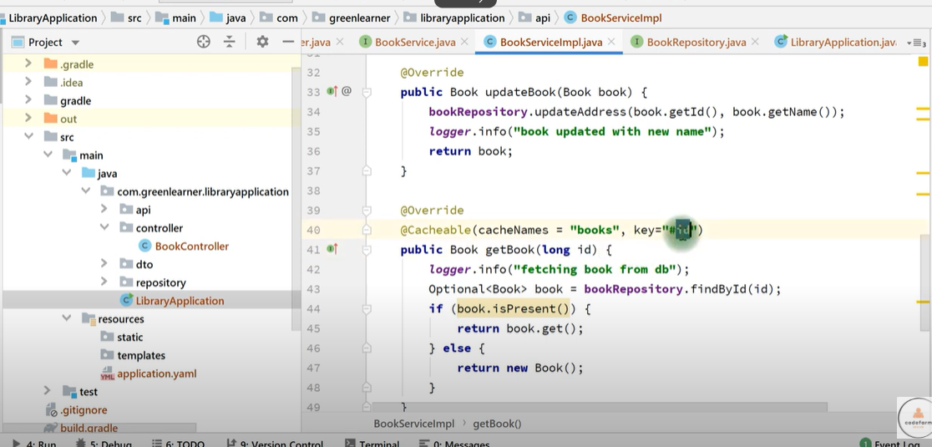  
  
  
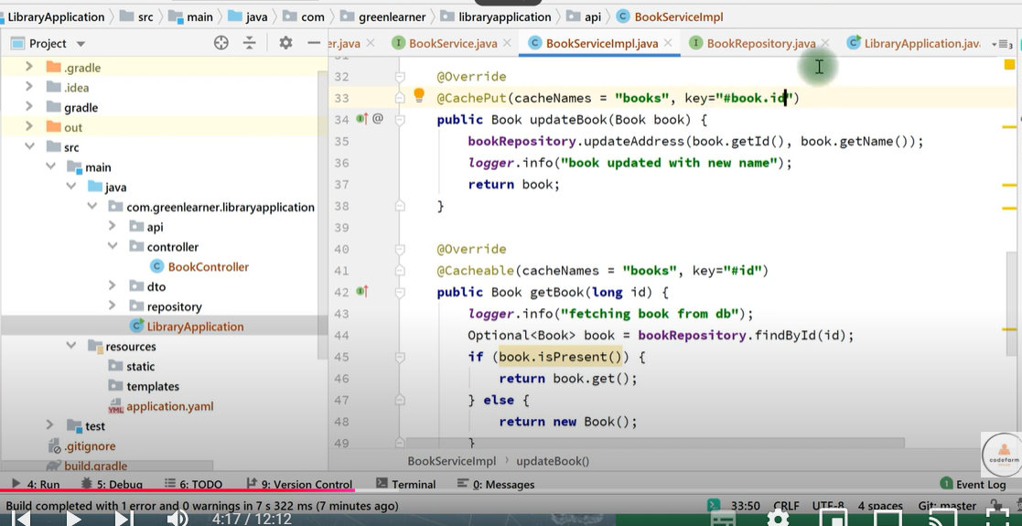  
  
  
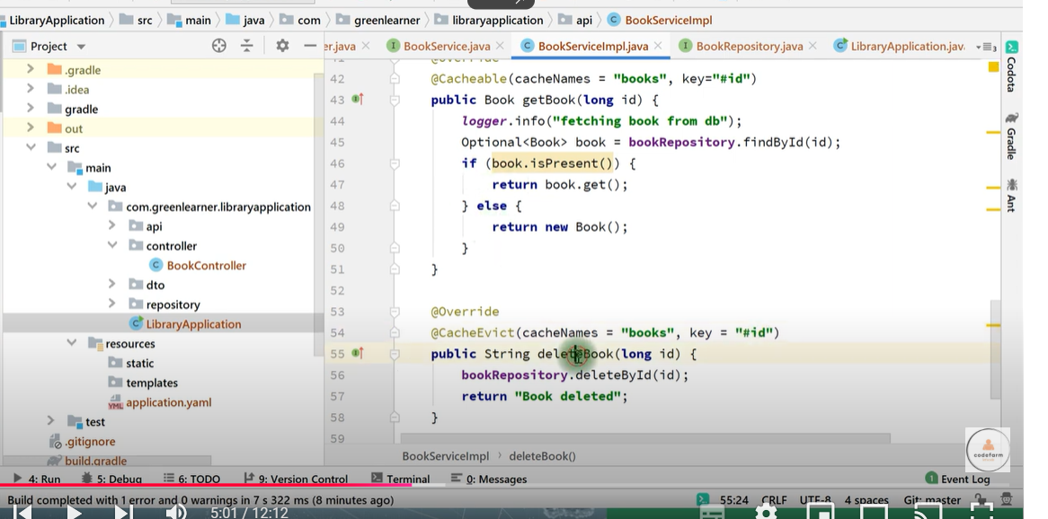  
  
  
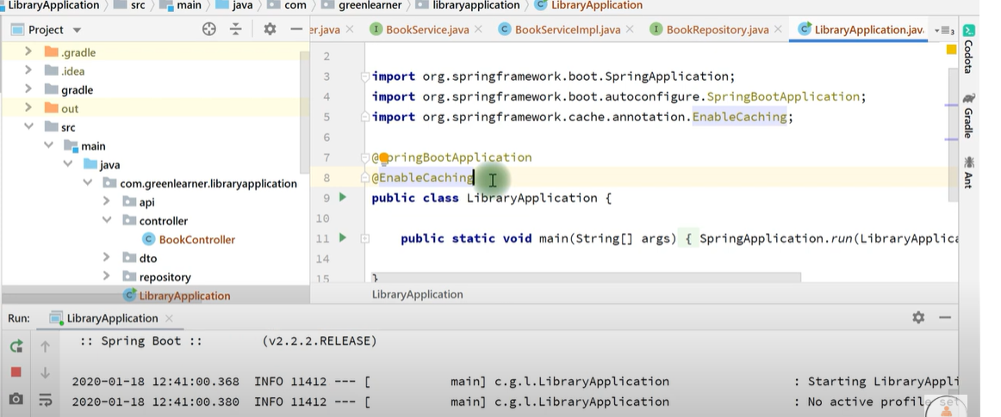  
  
  
 NO log Printed   
  
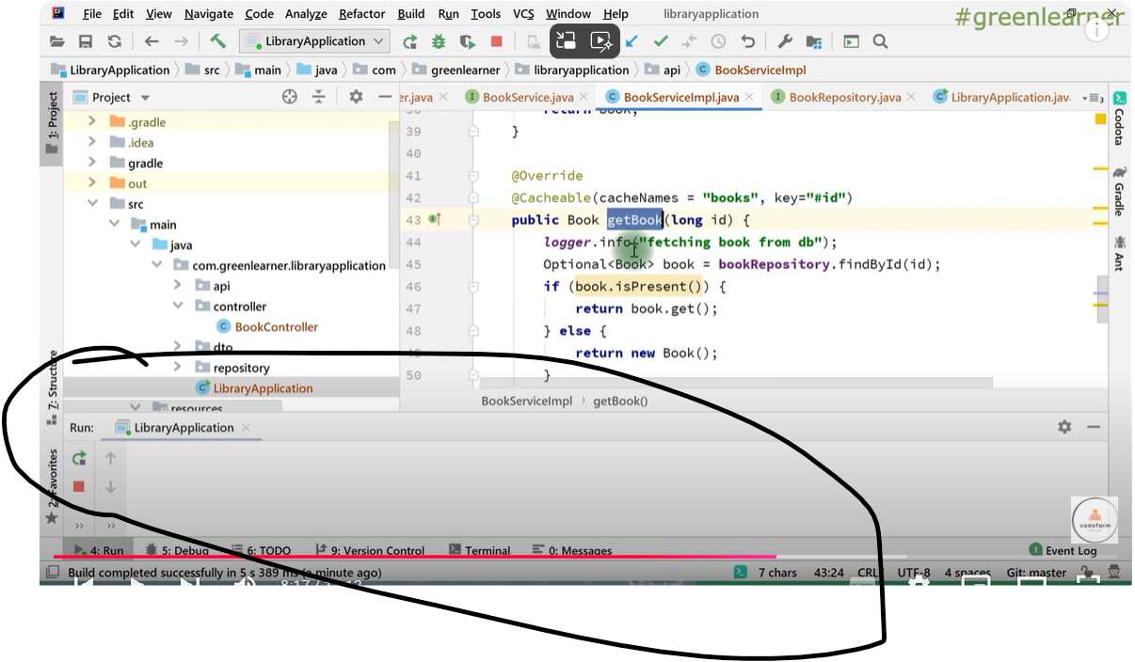

EHCHCHE  
  
  
  
  
